Improving Voting: Lessons learned from

Studies of Voting Systems and Ballots

DRAFT

Paul S. Herrnson
Center for American Politics and Citizenship
University of Maryland
3102 Morrill Hall
College Park, MD 20708

The 2000 U.S. presidential election exposed serious shortcomings in how Americans vote. Initial reports about the election documented “butterfly ballots,” “hanging,” “dimpled,” and “pregnant” “chads,” and other problems associated with election administration in Florida. Then, the faulty methods that some states used to maintain or update voter registration lists, the lack of uniform standards for dealing with late or imperfectly submitted absentee or military ballots, and the inconsistent or nonexistent rules governing ballot recounts made headlines. Claims of civil riots violations also were covered by the media. This was followed by coverage of the courtroom battles that ultimately decided the election’s outcome. After the initial public shock over the election, academic research brought greater rigor to the subjects that dominated media coverage. State governments responded somewhat unevenly to widespread calls for election reform (Palazzolo and Ceaser 2005). The federal government responded by passing the Help America Vote Act. Despite these efforts the controversial 2006 election in Florida’s 13th congressional district, decided by fewer than 370 votes and marred by more than 18,000 ballots in one county missing a vote for a congressional candidate, served to remind Americans that the systems they use to vote remain imperfect and in need of improvement.
This paper focuses on the set of problems that gave rise to the electoral crisis of 2000 and the most likely explanation for the controversy surrounding the 2006 congressional election in Florida: the usability of voting systems and ballots. The first section provides an overview of the findings generated by aggregate-level research on the effects of voting systems and ballots. The second section provides an overview usability research and discusses the results from a usability study of voting interfaces. The third section discusses some of the practical lessons learned from research on voting. The fourth section provides a recommendation for election reform involving using usability research methods and it outlines a method for conducting such tests.

Aggregate-Level Research on Voting Systems and Ballots
The initial political science research following the 2000 presidential election relied on aggregate data analysis techniques to compare different types of voting systems and ballots. Most of this research compared the numbers overvotes, undervotes, spoiled ballots, and residual votes (a summary measure) made by voters residing in jurisdictions that used different types of voting technologies and ballots.
With respect to voting systems, the major findings of this research are:
- Punch card voting systems have higher residual vote rates than other voting systems (Caltech/MIT 2001; Ansolabehere and Stewart 2005).
- Digital electronic recording (DRE) and paper ballot optical scan (opscan) systems have smaller residual vote rates than punch card and paper ballot systems (Alvarez and Hall 2008).
- Changing from punch card systems to DRE or opscan systems results in a significant reduction in residual votes (Stewart 2006).
With respect to ballots the major findings are:
- Poor ballot design can lead to enough voter errors to alter the outcome of an election (Wand et al. 2001).
- Ballot formats can cause voters to skip elections in the middle of the ballot (Frisina et al. 2008), lead to roll-off on long ballots (Lausen 2007) or result in voters failing to make selections on ballot questions (Kimball and Kropf 2008).
- Ballot formats can influence the number of undervotes, overvotes, and unrecorded votes (Kimball and Kropf 2005; Bullock and Hood 2002; Wattenberg et al. 2000).
- Election precincts with comprising lower income and less well educated citizens report higher levels of voter errors.
- Minorities are more likely than whites to perform more poorly at the polls (Knack and Kropf 2003).
Many of these findings have met with general acceptance. However, some researchers have questioned the validity of undervotes as a measure of voter error, in part, by drawing distinctions between intentional and unintentional undervotes (Herron and Sekhon 2005). Questions can be raised about analyses that rely on aggregate-level aggregate data because they are subject to the ecological fallacy. These findings also can be criticized because the research clumps together voting systems with extremely different interfaces for the purpose of statistical analysis. For example, various touch screen systems, a system with a dial and buttons, systems that present the entire ballot at one time, and systems that combine touch screens with paper printouts are all categorized as DREs.

Usability Research on Voting Systems and Ballots
What some have viewed as a number of disconnected flaws in the voting systems and ballots that were used to record, cast, and tabulate votes in 2000 and 2006 in Florida can be better understood as a set of related shortcomings in the usability of the voting interfaces. Usability (sometimes referred to as human factors) is an interdisciplinary research approach generally associated with computer scientists, design engineers, and organizational psychologists. Its goal is to improve human interaction with computerized interfaces. Usability studies typically assess systems in terms of accuracy, errors, user satisfaction, speed, “learnability,” efficiency, and “memorability”(Nielsen 1994, 2003). They use a variety of methodologies, including review by computer-interaction experts and laboratory studies that video-recorded and precisely code the amount of time and number of movements required to complete a task requires and various other aspects of the subjects’ efforts. Some usability research, including that studying voting, involves field studies (e.g. Herrnson et al 2008).
The main tenets of the usability literature are that systems with simple, straightforward end-to-end designs, involving fewer steps, requiring little user memory, providing confirmation of one’s actions, and offering system-based help are more effective than systems that have added complexity, require individuals to remember previous actions, do not provide assistance with cognitive tasks, and are inefficient in terms of the number of steps required to complete an action. The usability literature, like the literature on the digital divide (see e.g., Mossberger, Tolbert, and Stansbury 2003), recognizes that different users have different capabilities and needs, especially using computers (Riviere and Thakor 1996; Kubeck et al. 1996). Although some usability experts might object to this simplification, many of the goals of usability research can be summed up by the acronym KISS, for “Keep It Simple, Sweetie”—a favorite expression among little league coaches.
Usability research on voting interfaces avoids some of the shortcomings of aggregate data analysis and makes possible the rigorous testing of a wide range of hypotheses involving differences among voting systems, ballots, and voters’ background characteristics, including prior voting experience and political knowledge. Usability studies of elections involve directly observing human-voting system interactions. They focus on the impact that designs of voting systems and ballots have on the voting experience. Usability studies enable researchers to test for relationships among independent and dependent variables that cannot be studied using aggregate election results. Most important for avoiding potentially catastrophic errors, like those occurring in 2000 and 2006 in Florida, usability testing can take place prior to an election, making it possible to avoid potential problems before they occur. Aggregate data analyses may be able to detect some usability problems, but only after an election is over. Because they are not designed to directly observe voters’ interactions with voting systems and ballots, studies using aggregate data may be able to detect gross design flaws but are likely to ignore others. Usability research on six voting systems—an opscan system (ES&S Model 100), a standard touch screen system (Diebold AccuVote-Ts), a touch screen system with automatic advance navigation and a paper trail (Avante VoteTrakker), a touch screen system that uses zooming technology (Zoomable Prototype), a DRE system with a dial and buttons (Hart InterCivic eSlate), and a full-face voting system that presents the entire ballot at once (Nedap LibertyVote)—has provided some generalizations related to voter satisfaction, the need for help when voting, the ability to vote accurately, the amount of time and effort it takes to vote, and the impact of voters’ background characteristics on the voting experience (Herrnson et al. 2008; Conrad et al. 2009). These are important metrics for voters, election officials, and democracy. (Pictures of these voting systems are provided in Figure 1 in the Appendix).
With respect to voter satisfaction the major findings are:
- Voters express greater overall satisfaction when using the best performing touch screen system than when using systems that have less visible computerization, such as opscan systems, systems with dials and buttons, or systems that present the entire ballot at one time.
- Voters expressed greater confidence that their votes were accurately recorded on the top-rated touch screen systems than on an opscan system.
- Voters rated the top-rated touch screen systems the most favorably in terms of most aspects of the voting experience, including understanding how to use the system, change a vote, and correct a mistake.
- Voters rated systems that enabled them to control the voting process more favorably than the system that automatically advanced them through the voting process.
With respect to needing help when voting the major findings are:
- Fewer voters reported feeling the need for help when voting on the best performing touch screen system than when voting on systems with less visible computerization, including opscan systems and voting systems that present the entire ballot at one time.
- Fewer voters reported needing help with systems that enabled them to control the voting process than with the system that automatically advanced them through the voting process.
- Fewer voters needed more help when using a standard office bloc ballot than a ballot with a straight-party option or a party-column ballot.
With respect to casting a ballot accurately and as intended the major findings are:
- The most frequent voter error was casting a ballot for a candidate the voter did not intend to support, usually a candidate listed immediately before or after the intended candidate—not unintentional undervotes, overvotes, or residual votes.
- Voters made fewer errors when voting in elections where they were instructed to vote for one candidate (or one ticket, such as president and vice-president) than when they were instructed to select more than one candidate for a single office.
- Voters made more errors when they attempted to change a vote.
- Voters using a simple office bloc ballot committed fewer errors than those using a ballot with a straight-party option or a party-column ballot.
- When voting for president and vice president, voters made fewer errors on the best touch screen systems than on all of the other systems, including the opscan system.
- The best touch screen systems performed better than the opscan systems and systems with mechanical interfaces in elections that ask voters to vote for more than one candidate.
- The likelihood of committing an error that would result in a voided vote when casting a write-in vote was roughly 25 percentage points greater on an opscan system than on the DRE systems.
With respect to the human effort it takes to vote:
- It took the least time to vote on best touch screen system and the opscan system and the most time on the mechanical system (with the dial and buttons).
- It took the fewest physical actions to vote on the opscan system and the best touch screen system and the most physical actions to vote on the mechanical system.
With respect to the impact of voters’ background characteristics:
- Voters’ backgrounds have little impact on their satisfaction with different voting systems.
- Voters having little computer experience, low incomes, women, and the elderly are more likely to feel the need for help when voting.
- Younger, wealthier, better educated, whites, whose native language is English and that frequently used computers consistently vote more accurately than do others.
Of course, usability research on elections also has some shortcomings. It is interdisciplinary, requiring the skills of individuals from a number of disciplines. Depending on the approach used, it can be expensive, require the use of a usability lab, paid research subjects, and a fairly large and well-trained staff. It is to some degree contrived, as are all studies requiring experimental manipulations. For these reasons, large-scale academic usability studies of elections are rarely replicated.

Lessons Learned
Research based on aggregate-level data analysis and usability tests supports several lessons about voting. One lesson concerns the types of errors voters are most prone to make. Candidate selection errors, the most frequent form of error, also are the most harmful. When voters who forget to vote for a candidate (an unintentional overvote) or mistakenly vote for more candidates than is allowable (an overvote) they deprive their preferred candidate of one vote. When voters make a candidate selection error, they not only deprive their preferred candidate of a vote, they also give that vote to one of the candidate’s opponents—a much more costly mistake.
Other lessons include the importance of the recognizing differences among voting interfaces and voters. First, differences among the interfaces of various DRE voting systems can be just as important to the voting experience as the differences between DRE systems and opscan systems. The complexity of voting interfaces, including the amount of information they present at one time, the mechanisms voters use to record their selections, the amount of control the voter maintains over the voting process, the information presented on review screens, the accessibility of instructions and help functions, and the privacy voting systems offer, can influence voter satisfaction, the need for help, the time and effort it takes to vote, and voters’ abilities to cast their votes as intended. Second, simple straightforward office bloc ballots are easier for voters to use than ballots that include a straight-party option, party-column ballots, or ballots that allow individuals to select more than one candidate for a specific office. Third, the digital divide is alive and well in the polling place—different types of voters have different needs and face different challenges.
Another lesson involves the importance of using a variety of metrics to study voting. Voting accuracy is important, but so are the need for help, the amount of time it takes to vote, and voter satisfaction. Issues related to the need for help and time spent in the voting booth have direct implications for the allocation of voting systems and poll workers. Voter satisfaction and trust are extremely important for maintaining public support in democracies. Without them, legitimate concerns about election administration, voter discrimination, and election security can give way to conspiracy theories (Alvarez and Hall 2008). Lost in the debate over election security and technology is the more challenging and more fundamental issue of reviving public trust in the way Americans vote.

A Reform Recommendation
Perhaps the most important overall lesson to be derived from contemporary research on voting is the importance of usability testing. Such testing has been recommended by the Technical Guidelines Committee of the U.S. Election Assistance Commission in its Voluntary Voting System Guidelines (2007). Requiring states or counties to perform some realistic usability studies prior to purchasing a voting system, adopting a new ballot, or introducing any new voting system-ballot combination in an election is a basic reform that has the potential to improve voting. Moreover, such testing need not be onerous. It also need not require the services of a panel of human-computer interaction experts, a usability lab, or a large-scale field study. Indeed, the findings reported above (and elsewhere) can be used to limit the number of voting systems and ballot types to be tested. State laws and regulations also can help minimize the amount of testing needed. For example, an election official charged with selecting a new voting system need not test DRE systems if they have been prohibited by their state legislature. Similarly, party-column ballots and ballots that include a straight-party option also can be eliminated from testing in states that do not allow them. Limiting the number of voting systems and ballots involved in usability tests can reduce their complexity and the number of participants required.
Simplifying usability tests, however, should not be confused with conducting sloppy or unrealistic tests. Tests should use the same hardware that is under consideration for purchase, the same ballots that are under consideration for adoption, and any relevant combinations thereof. Short ballots that are programmed to ask voters to select their favorite movie starts, professional athletes, and the like are no substitute for ballots that resemble those voters encounter election day. The surroundings and conditions in which the tests are conducted should resemble an actual election as much as possible.
The individuals selected to participate in the studies should be as diverse as possible. It is more important to have a sample of voters that includes representatives of many types of local voters than it is to have a randomly drawn sample. Individuals should be included whose backgrounds vary by prior voting experience, computer usage levels, information about or interest in politics, education, income, race and ethnicity, native language, and gender. Individuals that have various physical challenges or disabilities, such as impaired eyesight, mobility, or cognitive abilities, also should be included because these factors have been shown to influence various aspects of the voting experience (Herrnson et al. 2008). Although party identification has not been found to influence voting, voters that identify with a major party, as independents, and perhaps even minor-party identifiers or apolitical voters should be included in studies to maintain their credibility with politicians and the public.
The aforementioned factors are important considerations for studies of voting interfaces, but study designs can vary. One design that has been used with considerable success relies on a simulated election. It can involve relatively few voters and rely on direct observation methods or limited quantitative methods. It involves the following basic steps:
- Program a voting system or print ballots that match those intended for use in an election. In a case where more than one system or more than one ballot is being tested, create one interface for each voting system-ballot combination under consideration.
- Create a voter guide that lists all of the offices and ballot questions that are included in the simulated election. It should resemble the nonpartisan sample ballots mailed to voters by election officials in some localities and published in many local newspapers. Each voter guide should have some unique identifying information, such as a unique name for a write-in vote. This information can be used to match all of the forms completed by the participant to the votes the participant actually cast.
- Provide an orientation to study participants instructing them to circle the names of the candidates and the answers to ballot questions that they prefer on the basis of the information provided in the voter guide. In addition to including information about candidates and ballot questions, the voter guide should instruct voters to do some things in the voting booth that occur with varying amounts of frequency, such as changing a vote, voting in an election that allows for the selection of more than one candidate, and casting a write-in vote. If the ballot being tested has a straight-party option, some but not all voters should be instructed to use it.
- Randomly assign participants to a voting interface and instruct them to vote on it by entering the selections they made on their voter guide. Observe their behavior closely and record visible difficulties, whether they received help while voting, and if so the type of help. If possible, record the amount it time it took them to vote.
- When participants are finished voting, ask them to complete a questionnaire about their experiences that uses scales to elicit their opinions about the interface’s ease of use, readability, the understandability of the ballot, whether they felt their vote was accurately recorded, whether they felt the need to ask for help, and other pertinent issues related to the systems under study. Invite them to further express their views about the voting experience on the questionnaire.
- Repeat steps 5and 6 until each participant has voted on each voting interface.
- Ask participants to complete a questionnaire to ascertain their prior voting experience, age, race, education level, and other relevant background information.
- Discuss the participants’ ratings of each voting interface and your observations of their experience to learn more about the interfaces’ strengths and weaknesses.
- Match the voter guides, questionnaires, and the votes each participant cast on each voting interface using their unique identifying information (e.g., a write-in vote). Classify voter errors as candidate errors, unintentional undervotes, or overvotes by comparing each participant’s selections in their voter guide to the votes the participant actually cast. Use descriptive statistics, such as frequencies and means to analyze voters’ levels of satisfaction, self-reported need for help, the actual help they received, and the number and types of errors they commit. Crosstabs and differences of means tests can be used to learn about the effects of participants’ backgrounds on their voting experiences.

Conclusion
Elections are the hallmark of democratic politics. Democracies guarantee virtually every adult citizen the right to vote. They also should provide their citizens with the means to cast their votes with accuracy, privately, without feeling the need to ask others for help, in a timely manner, and in a way that leaves them feeling satisfied with the voting experience. Some recent elections in the United States have fallen short of this standard, creating distrust among some citizens and giving rise to conspiracy theories about the legitimacy of elections and the government. Numerous aspects of the electoral process are in need of attention, including matters related to the accuracy of election rolls, voter intimidation, the security of paper-based and electronic voting systems, the rights of the disabled, systematic disparities in the quality voting equipment citizens are asked to use, and long-lines that result from the unequal distribution of that equipment. All are important. Nevertheless, the matter discussed in this paper—shortcomings in the usability of some voting systems and ballots—is associated with the biggest electoral debacle in recent U.S. history. A simple reform requiring some basic usability testing can go a long way toward improving voting and ensuring that the major shortcomings of the 2000 presidential election and the 2006 congressional election in Florida are not repeated.
Appendix: Voting Systems

Figure 1a. The ES&S Model 100 Figure 1b. The Diebold AccuVote-TS

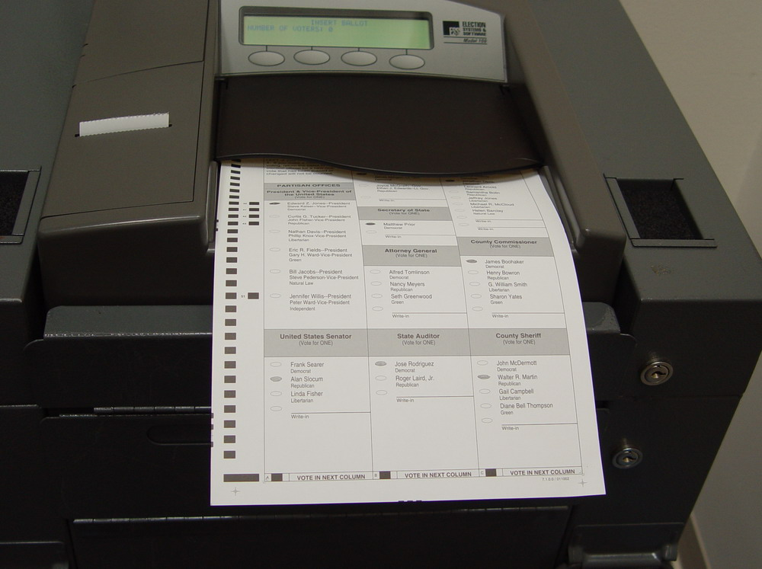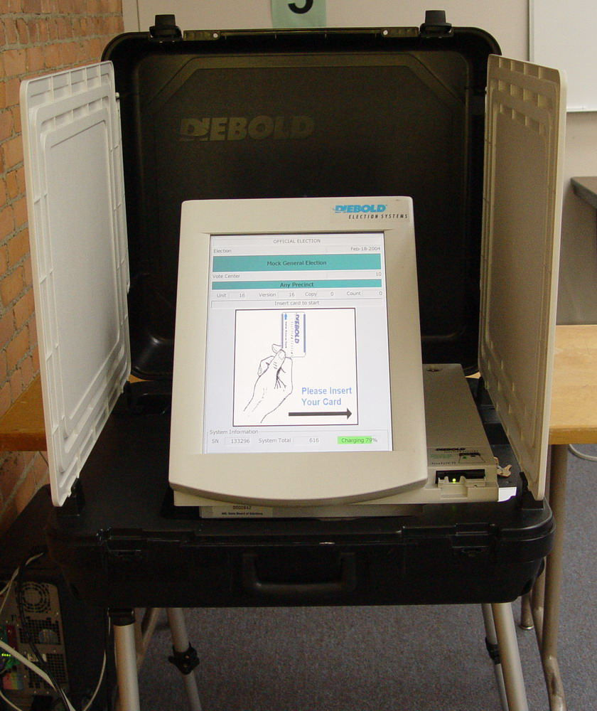

Figure 1c. The Avante Vote-Trakker

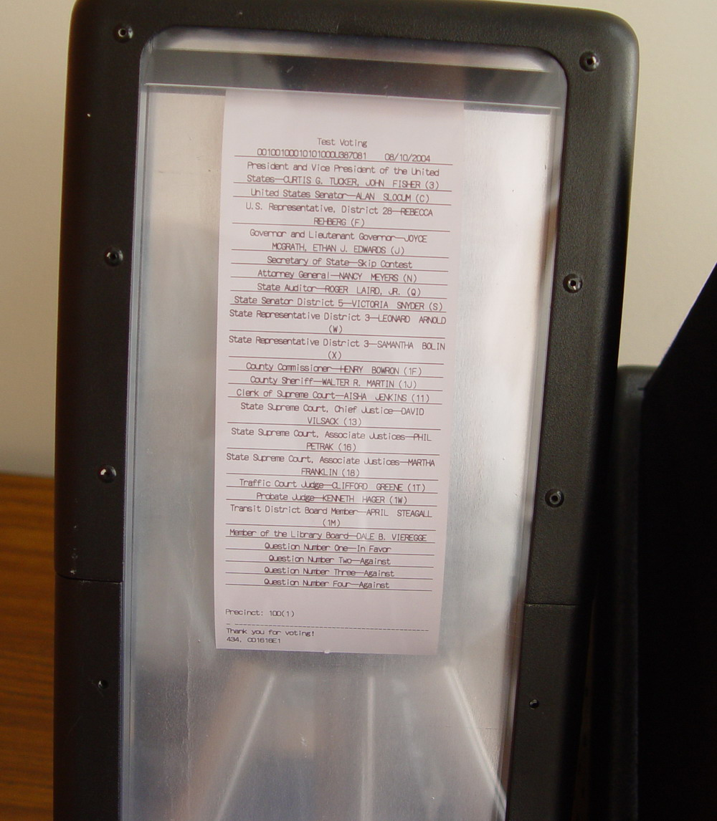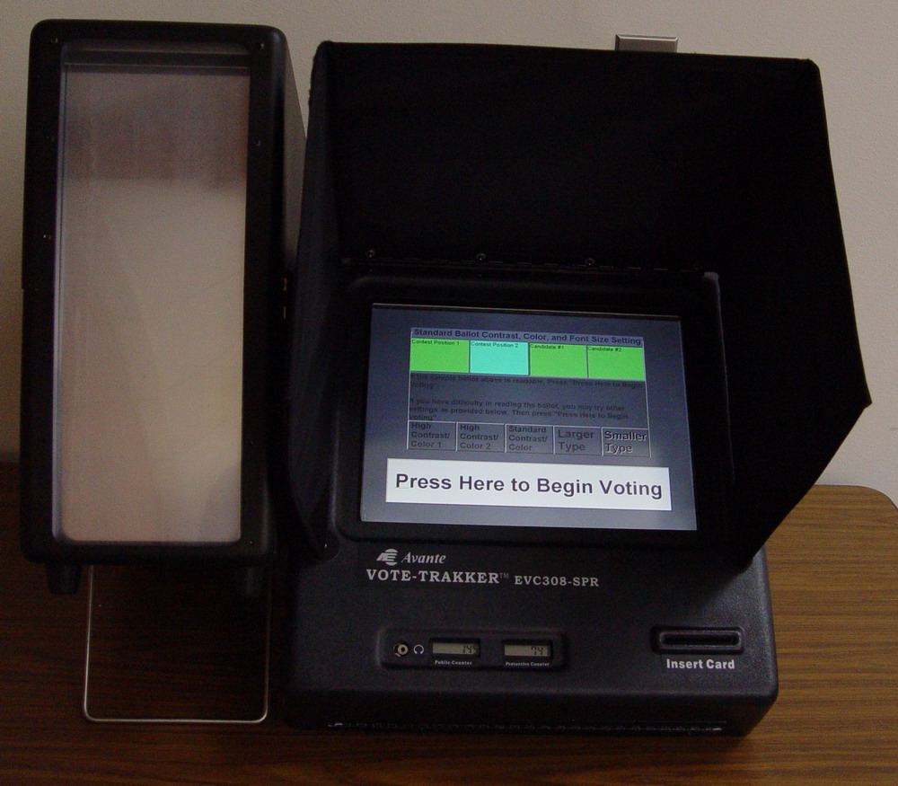
Figure 1d. The Zoomable Voting Prototype Figure 1e. The Hart InterCivic eSlate

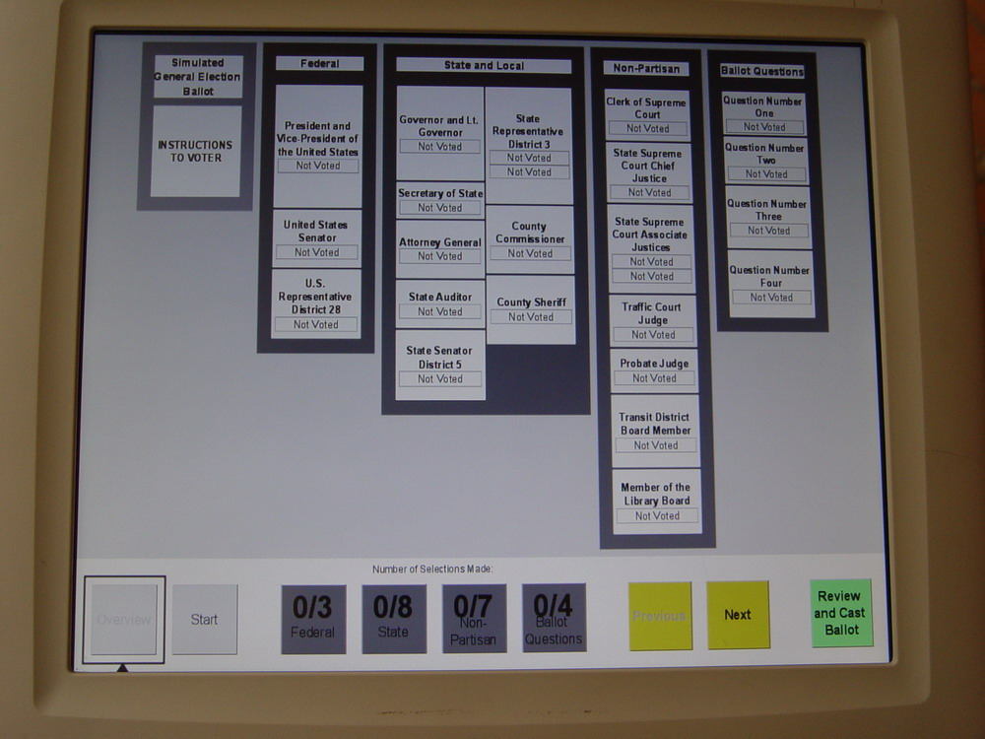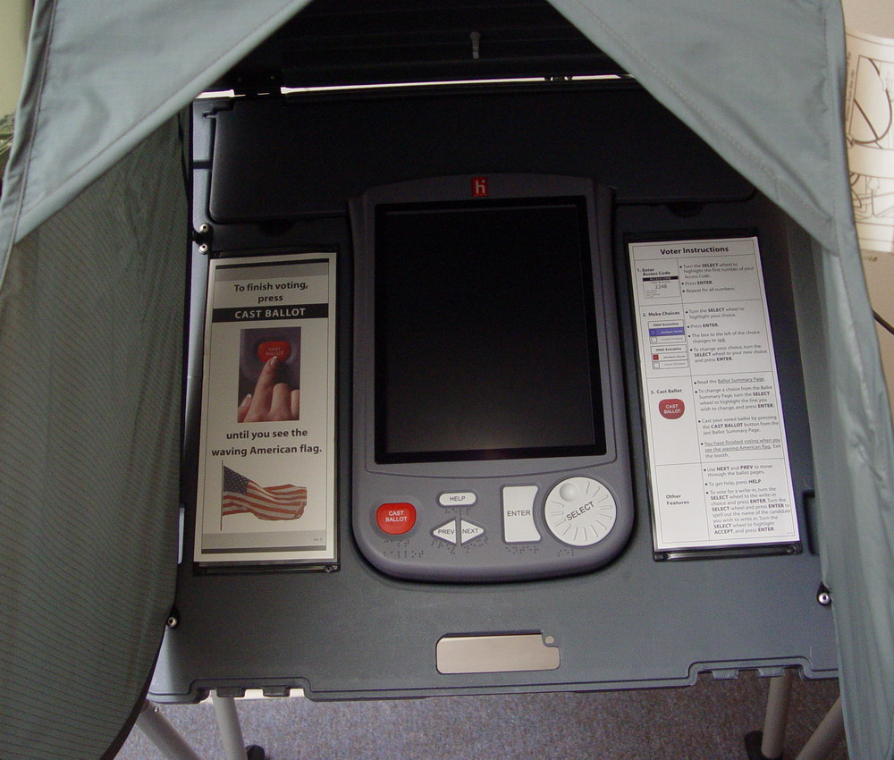

Figure1f. The Nedap LibertyVote

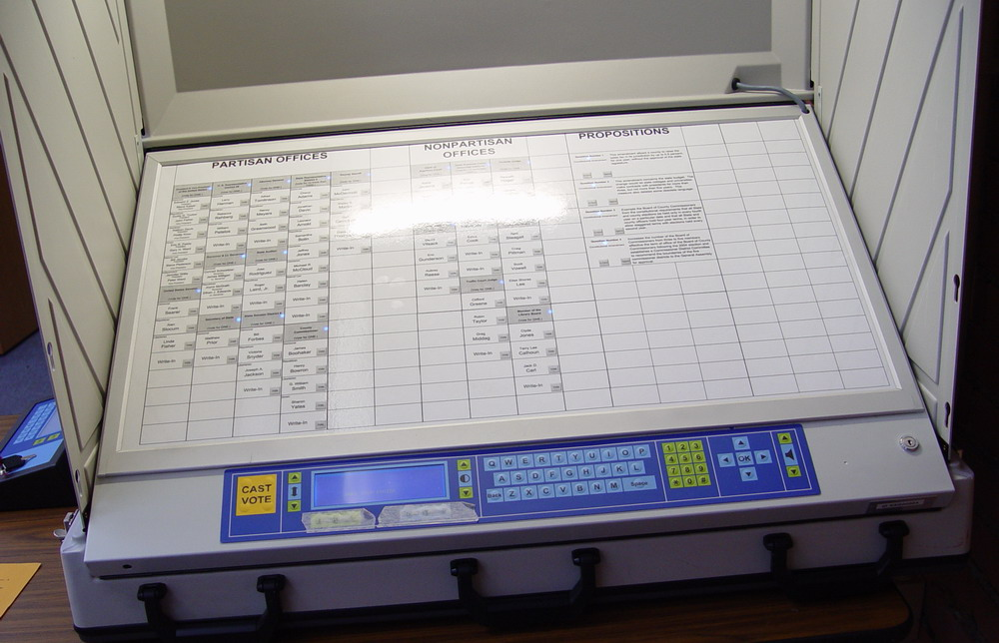
References

Alvarez, R. Michael. and Thad E. Hall. 2008. Electronic Elections: The Perils and Promises of
Electronic Democracy. Princeton: Princeton University Press.

Ansolabehere, Stephen, and Charles Stewart III. 2005. “Residual Votes Attributable to Technology.” Journal of Politics 67:365–89.

Bullock, Charles S., III, and M. V. Hood III. 2002. “One Person – No Vote; One Vote; Two Votes: Voting Methods, Ballot Types, and Undervote Frequency in the 2000 Presidential Election.” Social Science Quarterly 83:981-93.

Caltech/MIT Voting Technology Project. 2001. Voting: What Is, What Could Be, at http://www.vote.caltech.edu/media/documents/july01/July01_VTP_Voting_Report_Entire.pdf

Conrad, Frederick G., Benjamin B. Bederson, Brian Lewis, Emilia Peytcheva, Michael W. Traugott, Michael J. Hanmer, Paul S. Herrnson, Richard G. Niemi. 2009. “Electronic Voting Eliminates Hanging Chads But Introduces New Usability Challenges.” International Journal of Human-Computer Studies 67:111-124.

Herrnson, Paul S. Richard G. Niemi, Michael J. Hanmer, Benjamin B. Bederson, Frederick G. Conrad, Michael W. Traugott. 2008. Voting Technology: The Not-So-Simple Acto of Casting a Ballot. Washington, D.C.: Brookings Institution.

Herron, Michael, and Jasjeet S. Sekhon. 2005. “Black Candidates and Black Voters: Assessing the Impact of Candidate Race on Uncounted Vote Rates.” Journal of Politics 67:154-77.

Kimball, David C., Martha Kropf, and Lindsay Battles. 2006. “Helping America Vote? Election Administration, Partisanship, and Provisional Voting in the 2004 Election.” Election Law Journal 4: 447-61.

Kimball, David C., and Martha Kropf. 2005. “Ballot Design and Unrecorded Votes on Paper-Based Ballots.” Public Opinion Quarterly 69:508-29.

Kimball, David C., and Martha Kropf. 2008. “Voting Technology, Ballot Measures, and Residual Votes.” American Politics Research 36:479-509.

Knack, Stephen, and Martha Kropf. 2003. “Voided Ballots in the 1996 Presidential Election: A County-Level Analysis.” Journal of Politics 65:881-97.

Kubeck, Jean E., Norma D. Delp, Tammy K. Haslett, and Michael A. McDaniel. 1996. “Does Job-Related Training Performance Decline with Age.” Psychology and Aging 11:92-107.

Lausen, Marcia. 2007. Design for Democracy: Election Design. Chicago: University of Chicago Press.

Mossberger, Karen, Caroline J. Tolbert, and Mary Stansbury. 2003. Virtual Inequality beyond the Digital Divide. Washington, DC: Georgetown University Press.

Nielsen, Jakob. 1994. Usability Engineering. San Francisco: Morgan Kaufmann.

Nielsen, Jakob. 2003. Usability 101: Introduction to Usability at http://www.useit.com/alertbox/20030825.html.

Palazzolo, Daniel J.and James W.Ceaser. 2005. Election Reform: Politics and Policy. Lanham,Md.: Lexington Books.

Riviere, Cameron N., and Nitish V. Thakor. 1996. “Effects of Age and Disability on Tracking Tasks with a Computer Mouse: Accuracy and Linearity.” Journal of Rehabilitation Research and Development 33:6-16.

Technical Guidelines Development Committee. 2007. “Voluntary Voting System Guidelines Recommendations to the Election Assistance Commission.” http://www.eac.gov/program-areas/voting-systems/voluntary-voting-guidelines/docs/Final-TGDC-VVSG-08312007.doc/view?searchterm=vvsg

Wattenberg, Martin P., Ian McAllister, and Anthony Salvanto. 2000. “How Voting is Like Taking an SAT Test: An Analysis of American Voter Rolloff.” American Politics Quarterly 28:234-50.

Notes

Additional research was done on four vote verification/election audit systems. See Herrnson et al. 2008), 116-136.
For more detail see Herrnson et al. (2008).
Exceptions include the insane and those convicted of various crimes.

